* **Title Page: cs 1011-051 – Lab 6 <*House and BuildingCostEstimator*>**
* <Denise Malisa>
* <10/20/2020>
* <Page Break>
* **I. Objectives**

The program is supposed to calculate an estimate for the cost of two houses using details given by the user. Like the number of square feet, number of full bathrooms, half bathrooms, bedrooms, windows and garages. The program then generates estimated costs for two different houses the user specifies and compares the prices and displays the one which has a higher price and the one which has a lower cost.

* **II. Requirements**

I was supposed to create a UML for BuildingCostEstimator and create and implement BuildingCostEstimator class. The BuildingCostEstimator should have a method that will calculate the estimated cost based on user input.

* **III. Design:**

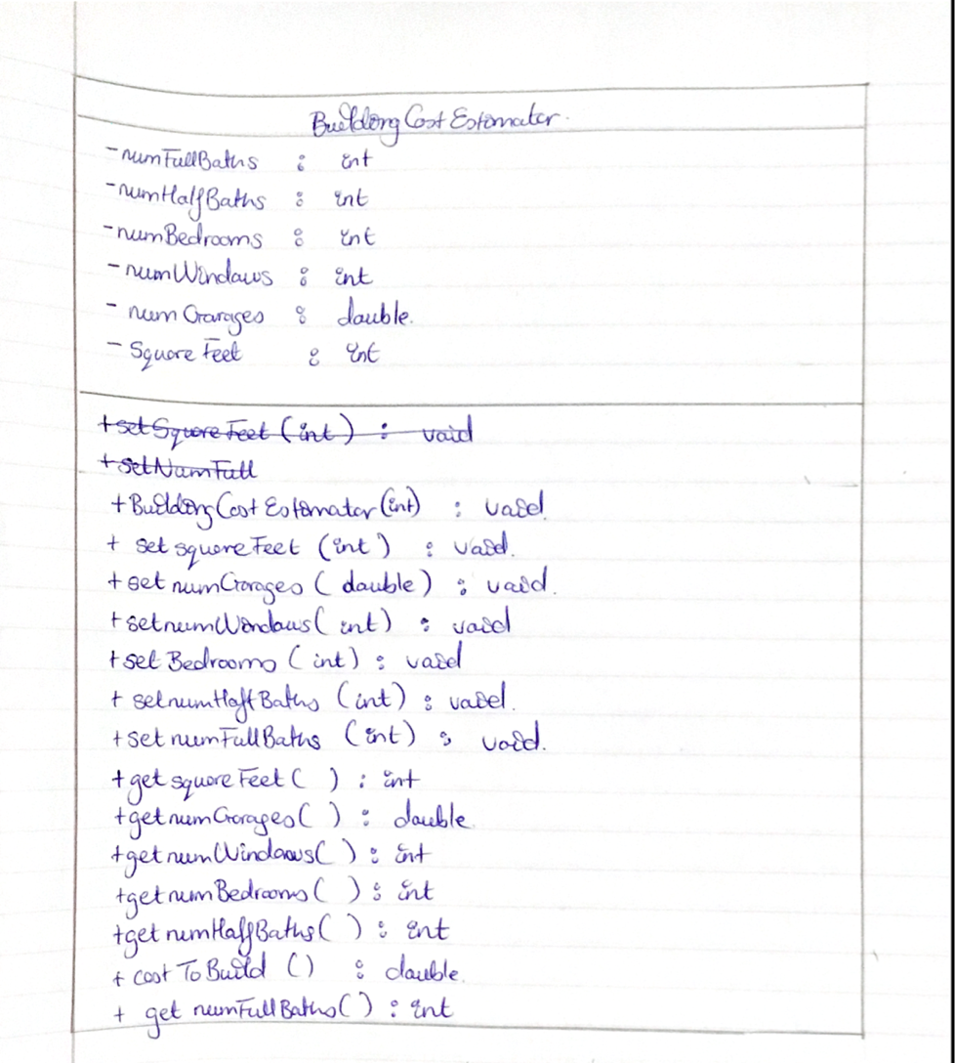

* **III. Test Plan/Test Strategy**

House 1:

|  |  |  |
| --- | --- | --- |
| Specifications | Number/amount | Total Cost |
| Square feet | 10000 | 1,350,000 |
| Full baths | 2 | 40,000 |
| Half baths | 1 | 7,000 |
| Bedrooms | 3 | 9,000 |
| Windows | 11 | 11,000 |
| Garage | 3.5 | 28,000 |
| Total |  | 1,445,000 |

House 2:

|  |  |  |
| --- | --- | --- |
| Specifications | Number/amount | Total Cost |
| Square feet | 50000 | 6,750,000 |
| Full baths | 3 | 60,000 |
| Half baths | 2 | 14,000 |
| Bedrooms | 4 | 12,000 |
| Windows | 18 | 18,000 |
| Garage | 5 | 40,000 |
| Total |  | 6,894,000 |

Expected results: the totals for each house respectively, and house 1 being less expensive and house two being more expensive.

* **IV. Results**

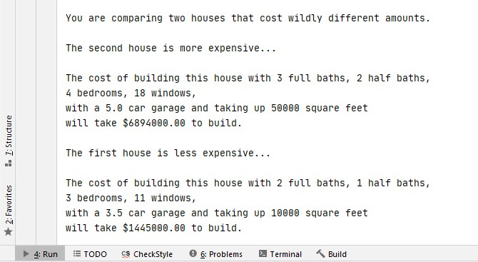

* **V. Discussion**

I learnt how to implement a user defined class and how to create a UML diagram. There was a huge learning point for me when my program wasn’t running and for two days, I couldn’t find the error only to see it was a spelling error with some of the attribute names when I was getting and setting.